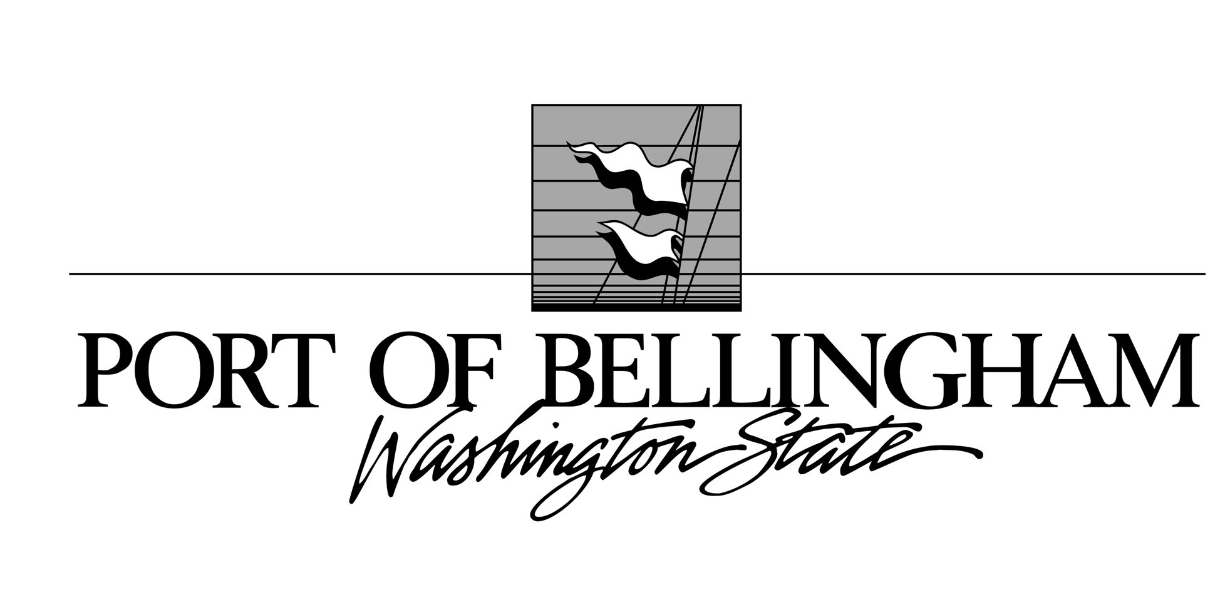

BLAINE & SQUALICUM HARBORS
- Moorage Rates -
FREQUENTLY ASKED QUESTIONS
Effective April 1, 2025

MOORAGE RATES
1. What are the monthly moorage rates for recreation vessels?
Squalicum Harbor
Open Slip-Recreation Boathouse

Rates are charged based on slip length or boat length, whichever is greater (Boathouse is charged on length of boathouse).

Blaine Harbor
Open Slip-Recreation Boathouse

Rates are charged based on slip length or boat length, whichever is greater (Boathouse is charged on length of boathouse).
2. Can I pay moorage annually?
Yes, we offer an annual moorage rate. If you choose to pay your moorage annually, the enrollment period to do so is March 3 through April 30. All recreation annual moorage renews on April 1 of each year.

3. What is the current annual moorage rate?
The annual moorage rate is discounted by a rate equal to a 5-year Treasury bond plus 1%. This rate adjusts annually on January 1. Effective January 1, 2023, the annual moorage rate is discounted 5%.

Annual Moorage Rates
Squalicum Harbor
Open Slip-Recreation Boathouse

Blaine
Open Slip-Recreation Boathouse

4. What are the moorage rates for Active Commercial Fishing Vessels?

Active Commercial Fishing Vessel
Monthly Moorage Rate

5. How does a boat qualify for the Active Commercial Fishing (ACF) rate?
To qualify for the ACF rate, the customer will need to provide proof of commercial fishing activity. Acceptable proof includes previous or current season fishing license, previous or
current season fish tickets or landing permits in the name of the vessel owner. Previous is defined as in the last two (2) years. The Active Commercial Fisherman will have the vessel which is moored in the harbor, rigged for licensed fishery (or fisheries). To continue eligibility for this rate, documents would need to be submitted to replace ones older than two (2) years.

6. What is Leasehold Excise Tax (LHT)?
Under RCW 82.29A, the State of Washington establishes an excise tax for the act or privilege of occupying or using publicly owned real or personal property which is exempted from property tax. The LHT is “in lieu” of the property tax and is intended to provide equity in taxation of all property. The LHT collected is passed onto the Washington State Department of Revenue.
7. Do my moorage rates pay for the landscaping and maintenance on the promenade around Squalicum Harbor?
No, they do not. The promenade is managed under the Port’s Open Space Program, which provides design, implementation and maintenance of the Port’s Public Access/Park System.
Funded by tax revenues for the benefit of the community, this program provides for the development of opportunities for public recreational and interpretive interactions with the Port’s unique properties and facilities. This is also how the Port funds its public parks.
8. How do the Port of Bellingham rates compare to other marinas?
A survey was done to gauge the rates of other marinas. The moorage rates shown in Table 1 are from the survey done January 10, 2025 and shows where our rates fit within the market.
Table 1

MOORAGE RATE MODEL
9. How does the Port Set Moorage Rates?
The Port has a moorage model that bases recreation rates on the recovery of actual expenditures for operating, capital, and financing costs. The marinas are a self-sustaining unit operating on marina revenues and bond financing, not on Whatcom County tax dollars.
The moorage rate model recovers all of the operating and capital costs of the harbors while also maintaining a cash reserve adequate for covering existing bonding requirements.
10. How does the Active Commercial Fishing rate fit with the moorage model?

The Commission spent a considerable amount of time researching and analyzing the benefits of what a reduced moorage program would be for the citizens of Whatcom County. After hearing public comment from the different sectors impacted by the local fishing fleet, the Commission wanted to implement a program that would lure fishermen mooring in other facilities to the Port of Bellingham, which would in turn lead to an increase in taxes being paid into Whatcom County as well as job creation and retention for local businesses.
During the 2014 review of the moorage model, the Port Commission directed Port Staff to develop a pricing strategy to establish and maintain a competitive moorage rate for ACF vessels while balancing the revenues needed to operate the marinas. The adopted moorage model incorporated a moorage rate for Active Commercial Fishing Vessels that links to the recreation rate for vessels 26’ and under. The difference between the ACF User Rate and the Effective Rate (<26’ rec rate) is paid by the Port’s Economic Development Dept.
The Port of Bellingham is committed to supporting the local commercial fishing industry and other marine-related businesses through the development of business-friendly policies and programs.

MARINA ADVISORY COMMITTEE
11. Who is the Marina Advisory Committee (MAC)?
The MAC is made up of representatives from the commercial fishing industry, recreational boating, marine support services (including port tenants), boating clubs, and other associated interests. The MAC is a Port of Bellingham, Commission-appointed committee directed to advise the port on planning, operations, policies, and other marina-related matters.

